Gain DashBOARD

[Food Systems Dashboard | GAIN](https://www.gainhealth.org/food-systems-dashboard)

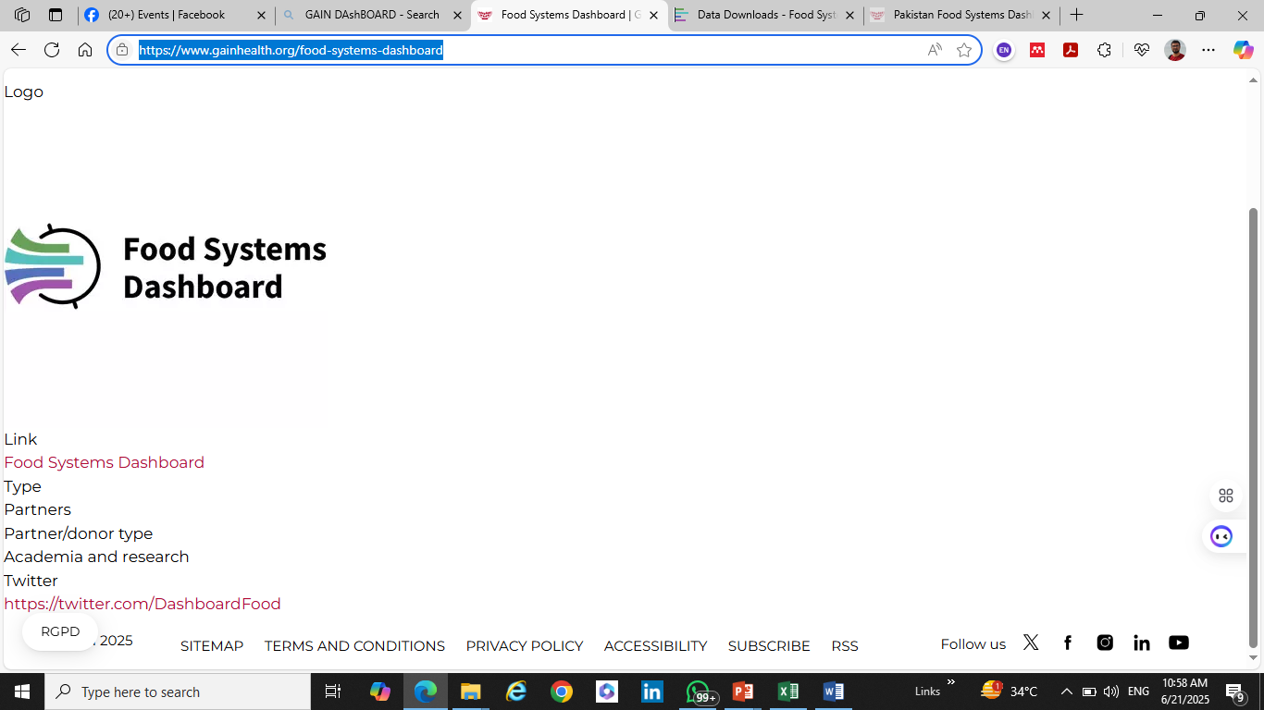

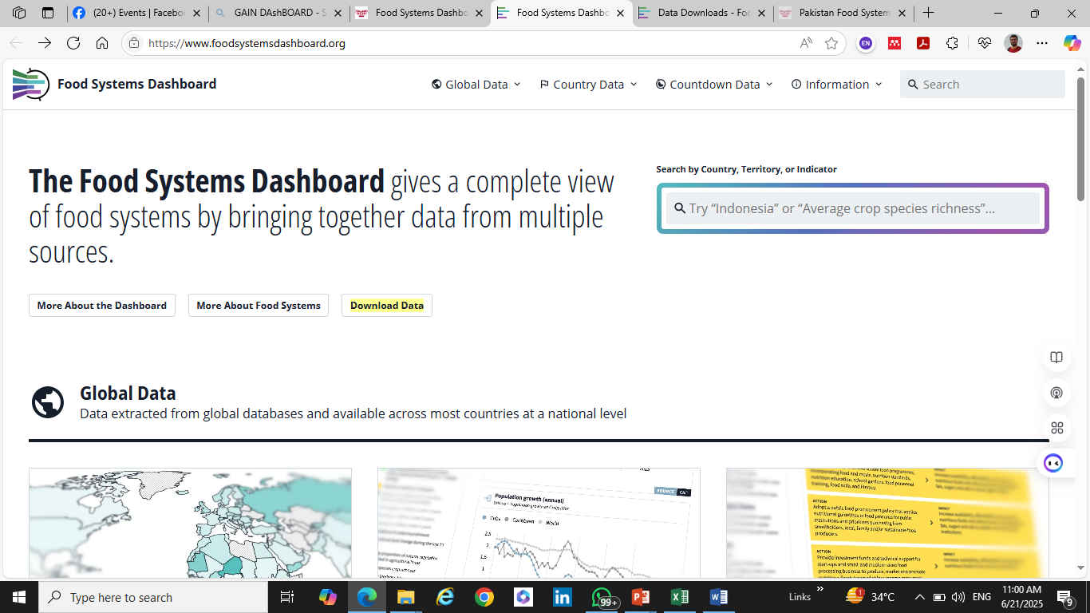

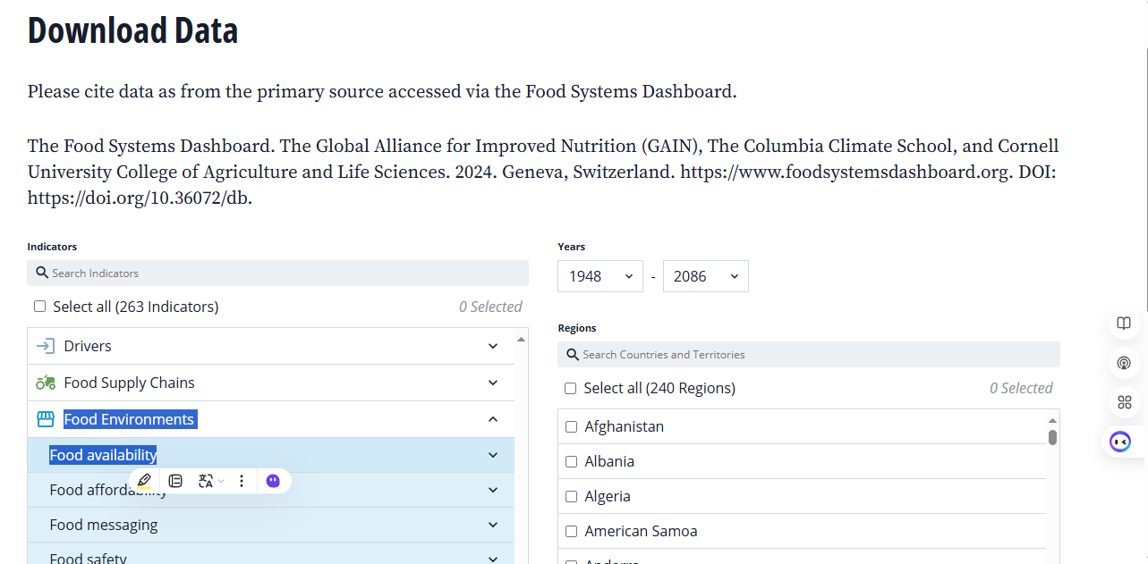

[Food Systems Dashboard](https://www.foodsystemsdashboard.org/countries/pak/subnational-data/indicators/admin-1/food-supply-chains/production-systems-and-input-supply/cereal-yield-maize/map)

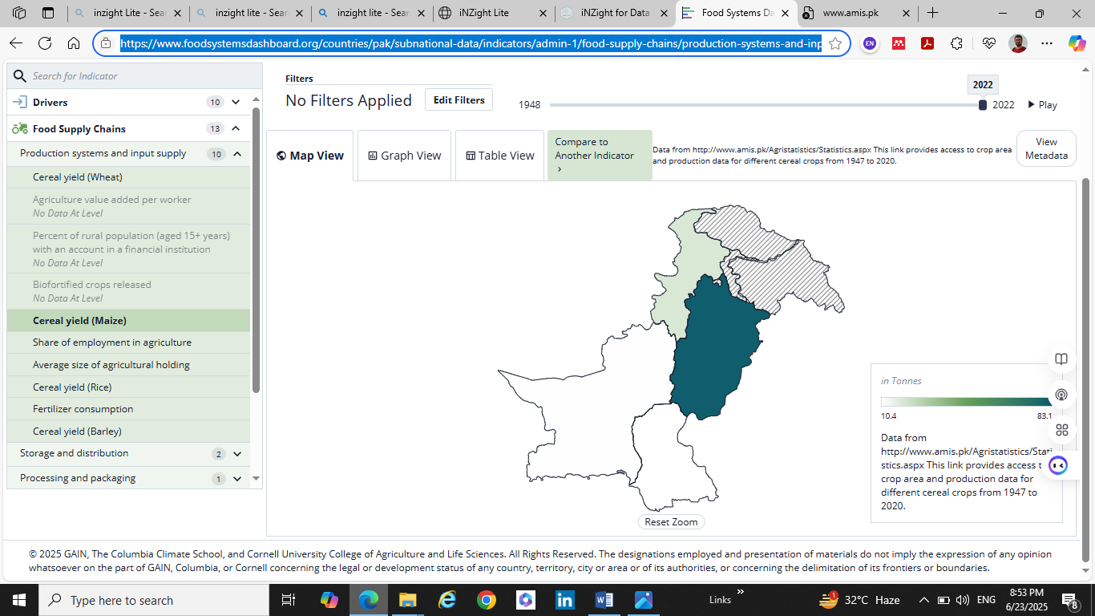

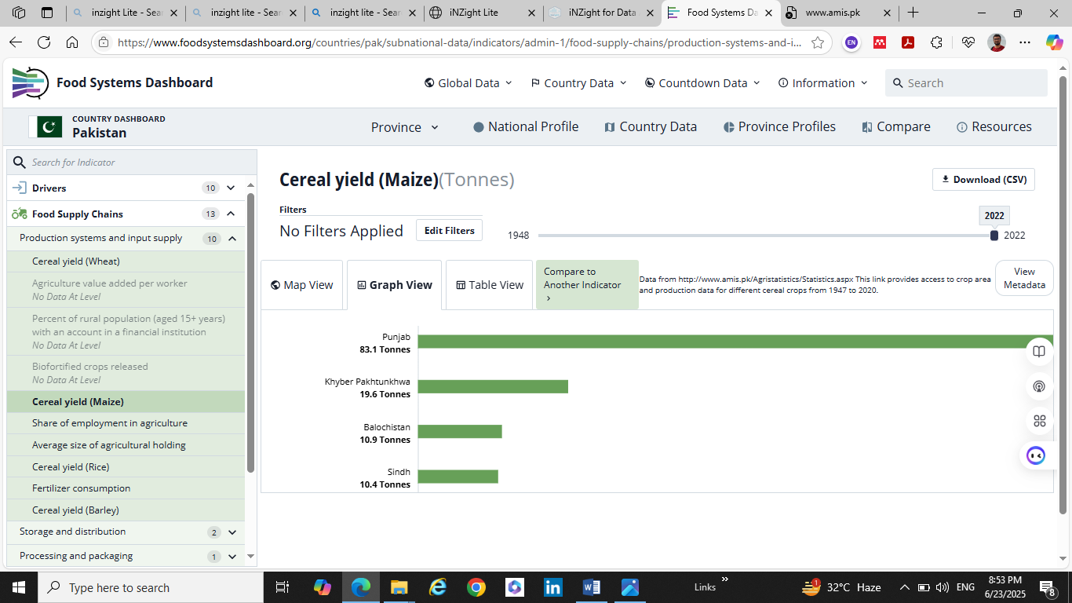

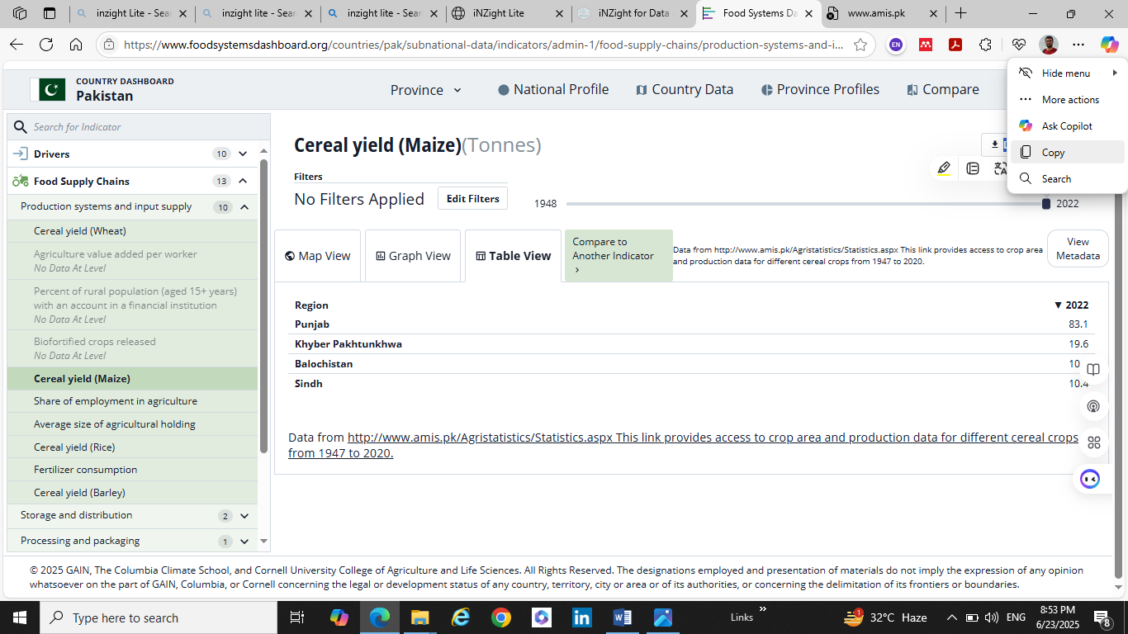

<https://www.bing.com/ck/a?!&&p=1ad810684de6ab2ce7f1407c5a52c847f1c6e91dd37e720665a599e567ca83c6JmltdHM9MTc1MDYzNjgwMA&ptn=3&ver=2&hsh=4&fclid=3f2f4a79-23a0-6917-23db-59c8223068cd&psq=inzight+Lite&u=a1aHR0cHM6Ly9saXRlLmRvY2tlci5zdGF0LmF1Y2tsYW5kLmFjLm56Lw&ntb=1>

[iNZight Lite](https://lite.docker.stat.auckland.ac.nz/)

