**What is the function of mercury in the Kjeldahl method?**

With the passage of time many changes have been recorded in order to get a more preferable method a new technique termed by the AOAC (Association Official Analytical Chemists)  has been introduced which favours micro Kjeldahl as well as macro Kjeldahl both. This process uses Mercury as a catalyst in order to trap ammonia then the process continues as such and later the standard acid solution is titrated against sodium hydroxide.

1. **What is the purpose of adding H2SO4 at the initial step of the Kjeldahl method?**

This method is fully based on a high boiling point. Salt and catalyst highly increase the speed of digestion. In addition, if potassium sulfate is added that increases the boiling point of sulfuric acid furthermore. Finally, the action of the catalyst makes the speed and efficiency of the digestion procedure more rapid, henceforth improving the analytical method.

1. **Conversion factors:**

The total Kjeldahl nitrogen depends on the type of protein also. To work with total Kjeldahl nitrogen, it's important to note what fraction of the protein is composed of nitrogenous amino acids.

The range of conversion is very low. For food, it generally ranges from 6.38 for meat, egg, maize; it is 6.25 for sorghum; it is 5.83 for rice, and so on.

**The Procedure involved in the Kjeldahl Method**

The working principle of Kjeldahl analysis is three steps process as described below:

1. **Digestion:**

The organic sample provided or taken is firstly treated with a concentrated acid solution, mostly H2SO4. The solution is boiled at an extremely high temperature. The acid solution digests the sample to produce ammonium sulfate solution.

1. **Distillation:**

The particular process is a combination of boiling and condensation. An excess of base is added to the formed solution to convert the ammonium sulfate solution to NH3 gas.

1. **Titration:**

To finally quantify the nitrogen present in the sample, the obtained product from the previous process is titrated in order to give the final required results.

This particular method left a huge impact. Furthermore, studies have improved the quality of the method. Various scientific associations approved this method to be one of the most versatile methods. These associations include AOAC(Association Official Analytical Chemists), AACC(Association of American Cereal Chemists), AOCS(American Oil Chemist Society), EPA(Environmental Protection Agency), ISO(International Standards Organization). The following are the names of some of the associations which lead the scientific equipment for conducting the Kjeldahl method.

[(466) Kjeldahl Method - YouTube](https://www.youtube.com/watch?v=DHVWkSU9Oyk&t=191s) https://www.youtube.com/watch?v=DHVWkSU9Oyk&t=191s

Digestion:

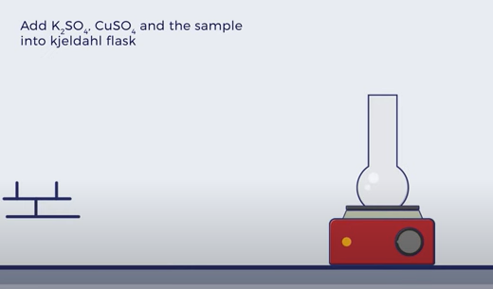

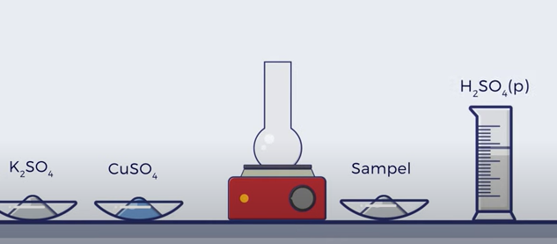

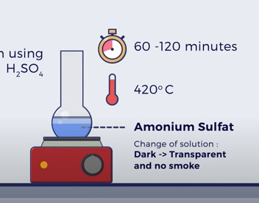

Distillation: Addition of 40% Soln of NaoH

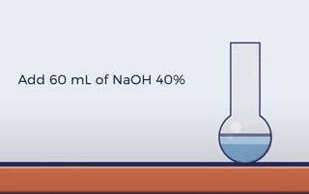

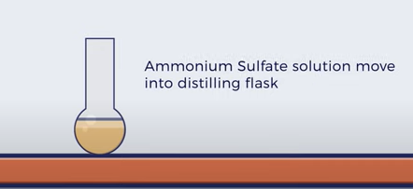

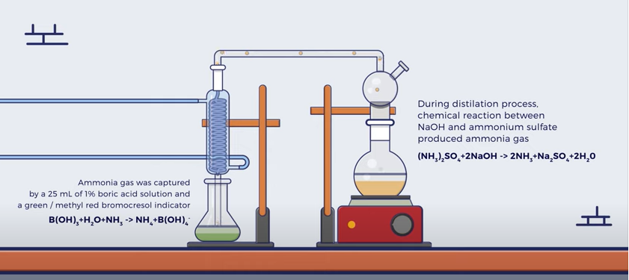

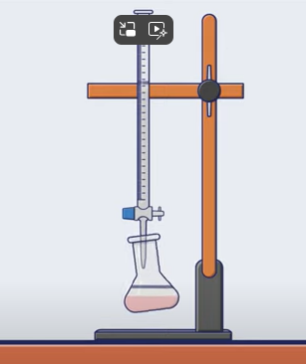Titration with 0.1 N HCl

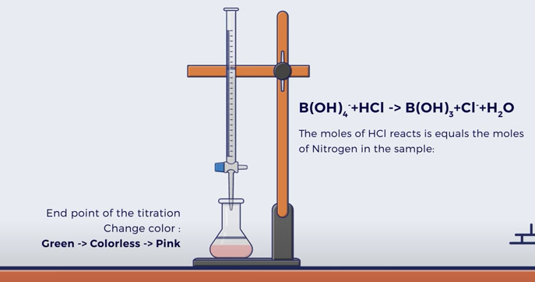

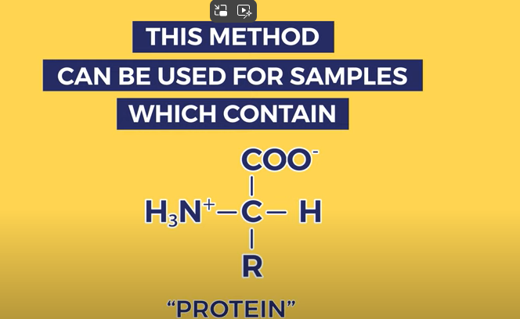



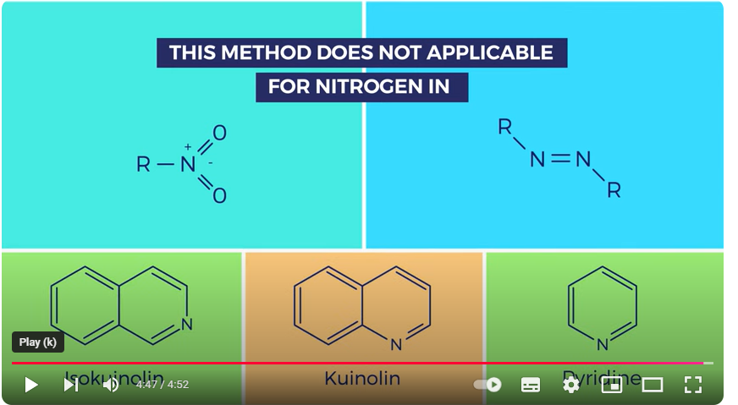

**Kjeldahl Method Reaction**

1. **Digestion:**

Organic (C, H, N) + H2SO4 → digest Cu2+ + (NH4)2SO4

1. **Distillation:**

(NH4)2SO4 + 2NaOH → Na2SO4 + 2H2O + 2NH3

And, NH3 + HCl → NH₄Cl

1. **Titration:**

B(OH)2 + H2O + Na2CO3 → NaHCO3 + CO2 + H2O

Note: Same steps are involved for protein estimation by the Kjeldahl method.

The equivalent weight of NH3 is 17g/eq. And, 14 gm of Nitrogen is contained one equivalent weight of NH3. So, the percentage of nitrogen can be determined using the following formula:

Kjeldahl method of nitrogen estimation = 1.4V × NW

Where,

W = Weight of the sample used (in grams)

V = Acid used in titration (in ml)

N = Normality of standard acid

### Limitations of Kjeldahl Method

This method measures only nitrogen bound to organic components (proteins, amino acids, nucleic acids) and ammonium in the sample. This method is not suitable for compounds containing nitrogen in azo and nitro groups or in rings (quinoline, pyridine, nitrate, and nitrite, etc). In these compounds, the nitrogen cannot be converted to ammonium sulfate following the Kjeldahl method.